|  |  |  |  |  |  |  |  |  |
| --- | --- | --- | --- | --- | --- | --- | --- | --- |
| |  | | --- | | **Drawing a Straight Line using OpenGL with GLUT** |         **SUBMITTED BY**   |  |  |  | | --- | --- | --- | | Name | ID | Section | | Kabid Yeiad | 202-15-14440 | 57_A |   **SUBMITTED TO**  **Deawan Rakin Ahamed Rema,**  **Lecturer**  **Dept. of CSE**  **Daffodil International University**   |  | | --- | |  |   Submitted on November 1, 2023 |

**Drawing a Straight Line using OpenGL with GLUT**

**Code:**

#include <GL/glut.h>

void display() {

    glClear(GL_COLOR_BUFFER_BIT);

    glColor3f(1.0f, 1.0f, 1.0f);

    glBegin(GL_LINES);

        glVertex2f(50.0f, 50.0f);

        glVertex2f(200.0f, 200.0f);

    glEnd();

    glFlush();

}

void init() {

    glClearColor(0.0f, 0.0f, 0.0f, 1.0f);

    glMatrixMode(GL_PROJECTION);

    glLoadIdentity();

    gluOrtho2D(0.0, 400.0, 0.0, 400.0);

}

int main(int argc, char** argv) {

    glutInit(&argc, argv);

    glutInitDisplayMode(GLUT_SINGLE | GLUT_RGB);

    glutInitWindowSize(400, 400);

    glutCreateWindow("Straight Line");

    init();

    glutDisplayFunc(display);

    glutMainLoop();

    return 0;

}

**Output:**

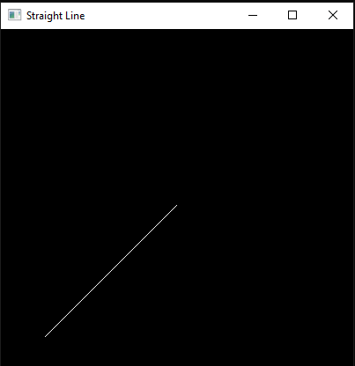

**Graph**:

**Discussion:**

In this experiment, we utilized OpenGL in conjunction with GLUT to draw a straight line. The code provided establishes the OpenGL environment, defines the coordinate system, and renders a line from the point (50, 50) to the point (200, 200). The output of the program clearly demonstrates the line drawn on the window as expected. This verifies that our OpenGL setup and drawing commands are functioning correctly. Additionally, we have included a graph to further illustrate the coordinates and path of the straight line. As seen in the graph, the line originates from (50, 50) and extends to (200, 200), following a linear path.